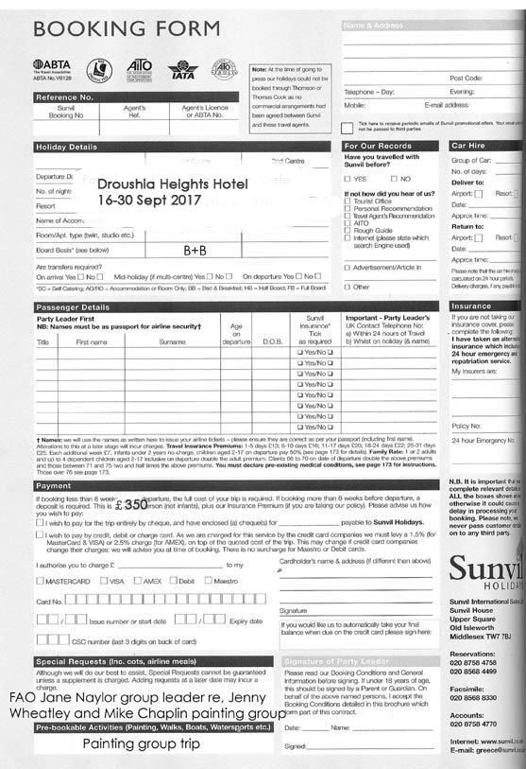

Name (as appears on your passport)……………………………………………..
Contact number/email……………………………………………………………..
Travel insurance details……………………………………………………………….
For Flight arrangements) Date of birth……………………………………………
Passport number………………………………………………………………………
Passport issue date…………………………………………………………………..
Passport place of issue………………………………………………………………..
Passport expiry date………………………………………………………………….
Country of residence………………….Nationality……………………………..

